Bahria University,
Karachi Campus

COURSE: SOFTWARE CONSTRUCTION
TERM: FALL 2025, CLASS: BSE-5C

PROJECT NAME

QATAAR(E-QUEUE SYSTEM)

Group Members List:

Name | Enrollment No
FIZA KHAN (Team Lead) | 02-131232-048
ALISHBA MAQSOOD | 02-131232-118
MUHUMMAD ABUBAKAR AFZAL | 02-131232-052

Submitted To:
Engineer. Muhammad Qasim

Submitted On:
__22/12/25__
(Date: DD/MM/YY)

Signed Remarks: Score:

1. Executive Summary
Traditional queue management systems require customers to wait physically at service centers, leading to overcrowding, long waiting times, and inefficient service delivery. Customers often lack information about their queue position and expected waiting time, which results in frustration and poor time management.
QATAAR is a mobile-based electronic queue management system designed to digitize the queuing process. The system allows users to generate service tokens remotely, view real-time queue status, and receive notifications when their turn is near. This reduces physical waiting and improves transparency for customers.
The system also assists service providers by enabling real-time monitoring and management of queues, leading to improved operational efficiency. QATAAR is developed using Flutter for cross-platform mobile support and Firebase for authentication, database management, and push notifications. Mapbox API is used to estimate travel time and enhance user alerts.
Overall, QATAAR provides an efficient, user-friendly, and scalable solution for modern queue management while demonstrating key software construction principles.

2. Project Definition
2.1 Problem Statement
In many service-based organizations such as hospitals, banks, and government offices, customers are required to wait in long physical queues. This results in overcrowded waiting areas, inefficient service delivery, and wasted time for both customers and staff. Customers have no clear information about their position in the queue or expected waiting time, while service providers struggle to manage large crowds effectively. These issues highlight the need for a digital solution to manage queues efficiently.

2.2 Scope & Boundaries
The scope of the QATAAR system includes the development of a mobile application that enables users to generate digital tokens remotely and monitor queue progress in real time. Users can select service categories and branches, view their queue position, and receive notifications when their turn is approaching. The system also includes location and traffic-based travel time estimation using Mapbox API.
The project is limited to queue and token management functionalities. Features such as online payment processing, advanced analytics, and multi-language support are not included in the current implementation and are considered future enhancements.

2.3 Vision and scope document summary
The vision of QATAAR is to provide a smart, reliable, and user-friendly electronic queue management system that reduces waiting time and overcrowding in service centers. The system aims to improve transparency, enhance customer experience, and support service providers in delivering efficient and organized services through the use of modern mobile and cloud technologies.

3. Requirements
3.1 Functional Requirements
The QATAAR system must provide the following functional capabilities:
- User Registration & Login
The system shall allow users to sign up and log in using email/password and Google authentication through Firebase.
- Profile Management
Users shall be able to view and update their profile information and securely log out of the system.
- Service Selection
The system shall allow users to browse available service categories (e.g., banking, hospital, passport office) and select a specific branch.
- Token Generation
The system shall generate a unique digital token for the selected service without requiring physical presence.
- Queue Tracking
Users shall be able to view their real-time position in the queue along with estimated waiting time.
- Notifications
The system shall send push notifications to alert users when the queue is moving and when their turn is approaching.
- Token History
The system shall maintain a record of previously generated tokens and their statuses.

3.2 Non-Functional Requirements
The system must meet the following non-functional requirements:
- Performance
Queue updates and notifications shall be delivered in real time with minimal delay.
- Scalability
The system shall support multiple service centers and a large number of concurrent users.
- Security
User data and authentication shall be securely managed using Firebase security rules.
- Usability
The application shall provide an intuitive and user-friendly interface suitable for users of all age groups.
- Reliability
The system shall ensure high availability and consistent performance with minimal downtime.

3.3 User Stories with Acceptance Criteria

User Story 1:
As a customer, I want to generate a token remotely so that I do not have to wait physically at the service center.
Acceptance Criteria: The token is generated successfully and displayed on the queue status screen.

User Story 2:
As a user, I want to view my real-time queue position so that I can manage my time efficiently.
Acceptance Criteria: The queue position updates automatically without manual refresh.

User Story 3:
As a user, I want to receive notifications when my turn is near so that I can arrive on time.
Acceptance Criteria: A push notification is sent
when the token reaches a predefined threshold.

4. System Design & Architecture
4.1 UML Diagrams

Dataflow Digram:
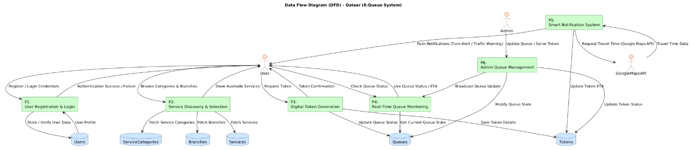

Context Digram:
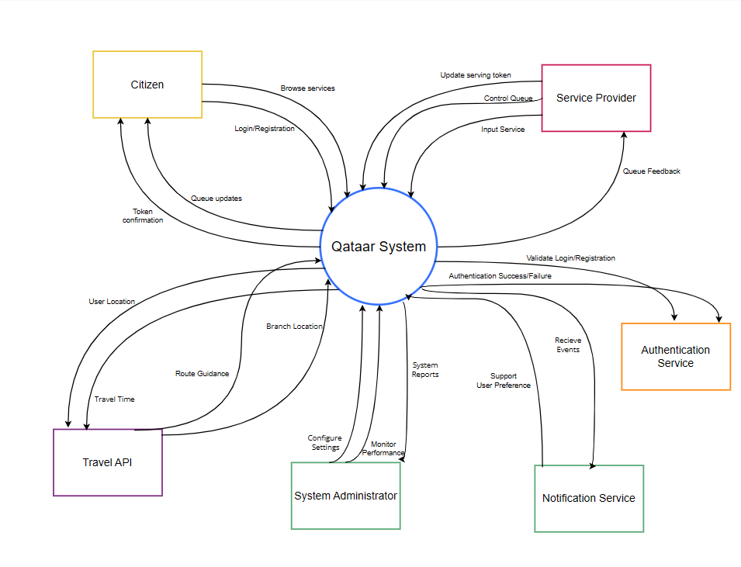
CLASS DIGRAM:
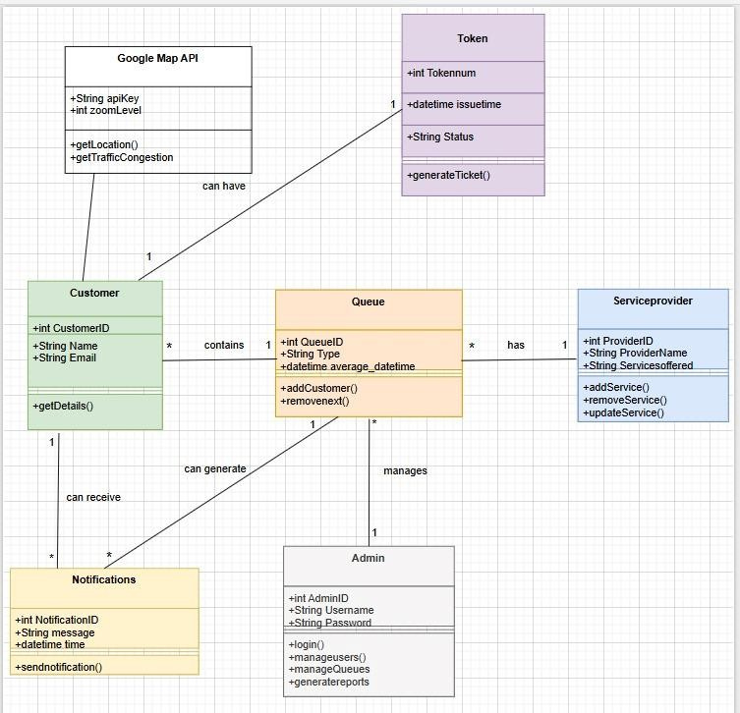

ERD Diagram
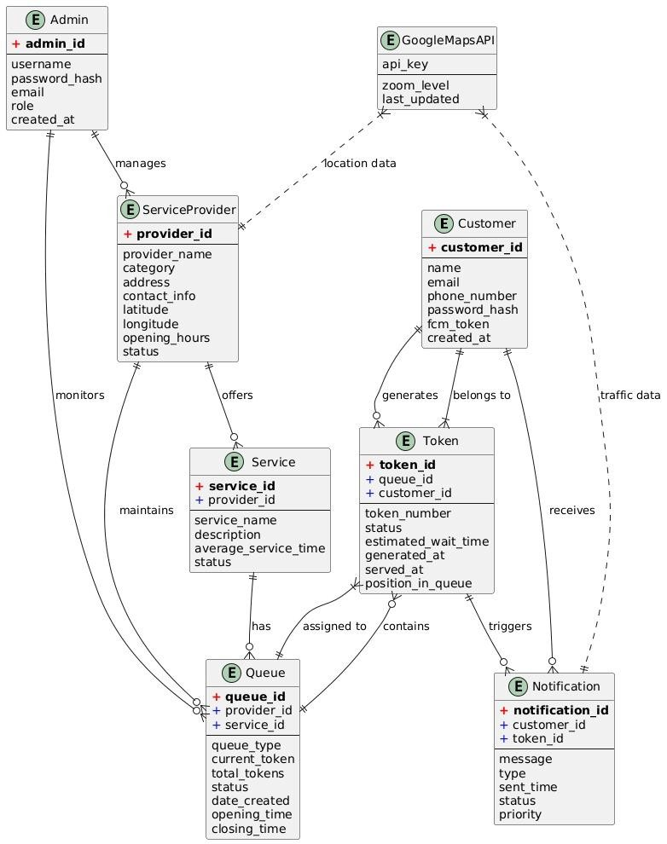

Sequence Diagram:
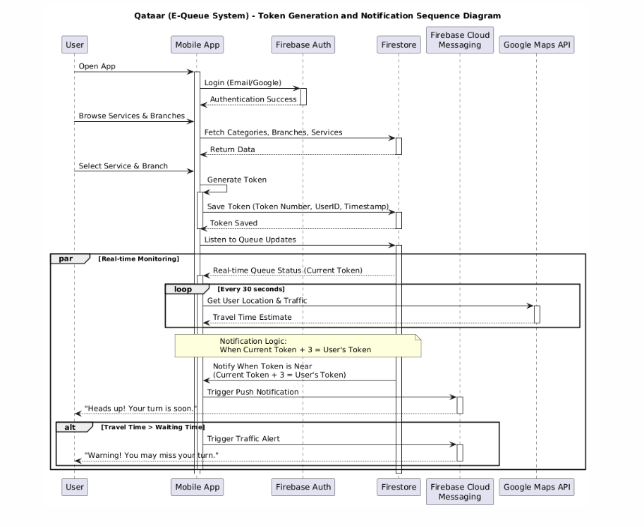

4.2 System Overview
QATAAR follows a client–server architecture where the Flutter-based mobile application acts as the client and Firebase serves as the backend. The mobile app handles user interactions such as authentication, service selection, token generation, and queue tracking. Firebase Authentication ensures secure login, while Cloud Firestore stores and updates user, token, and queue data in real time.
Firebase Cloud Messaging is used to send push notifications when the queue progresses or the user’s turn is near. The system also integrates the Mapbox API to estimate travel time based on user location and traffic conditions. This architecture ensures real-time updates, scalability, and ease of maintenance while supporting future system enhancements

4.3 Design Decisions and Justifications:
Flutter was selected for application development to enable cross-platform support with a single codebase and consistent user interface. Firebase was chosen as the backend due to its real-time database capabilities, built-in authentication, and scalability, which are essential for managing live queue updates.
A client–server architecture was adopted to separate frontend and backend responsibilities, improving maintainability and scalability. Real-time listeners were used to ensure instant queue updates without manual refresh. Additionally, Mapbox API was integrated to provide location and traffic-based travel time estimation, enhancing notification accuracy and user experience.
5. Implementation Details
5.1 Technology Stack
The QATAAR system is developed using Flutter for mobile application development, enabling cross-platform compatibility. Firebase Authentication is used for secure user registration and login, while Cloud Firestore manages real-time storage of user, token, and queue data. Firebase Cloud Messaging (FCM) is used to send push notifications, and Mapbox API is integrated for location and traffic-based travel time estimation.

5.2 Code Structure
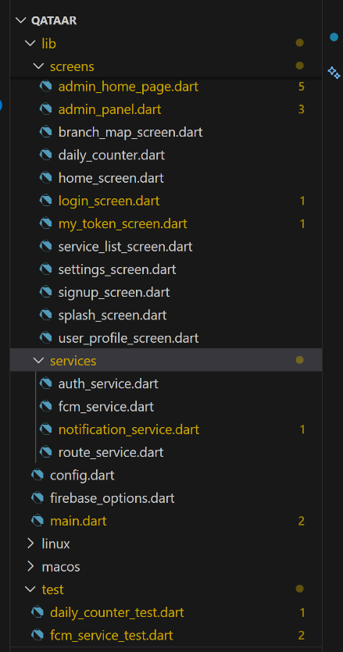
The application follows a modular code structure where each feature is implemented in separate modules. Key modules include authentication, user interface, token management, queue handling, notifications, and location services. This structure improves readability, maintainability, and supports parallel development by team members.

5.3 Key Logic
The token generation logic assigns a unique token number based on the selected service and branch. Queue position is calculated dynamically by counting active tokens ahead of the user. Estimated waiting time is computed using average service time per token. Real-time updates are handled using Firestore listeners to ensure instant data synchronization.
- Token Generation:
currentToken = branch.currentToken + 1
dailyTokenCounter += 1
tokenNumber = currentToken
estimatedWait = currentToken * avgServiceTimeSec

5.4 Mutability Concepts
Immutable data models are used where possible to prevent unintended data changes and improve system reliability. When updates are required, new instances of objects are created instead of modifying existing ones. This approach reduces bugs and makes the code easier to debug and test.

5.5 Code Refactoring
Code refactoring was applied to improve readability and performance. Repetitive logic was extracted into reusable functions, and complex methods were simplified. This resulted in cleaner code, reduced duplication, and easier maintenance.

1. Branch Loading & Firestore Handling
Before:
Future<void> loadBranches() async {
QuerySnapshot categoriesSnapshot =
await FirebaseFirestore.instance.collection('categories').get();

List<Map<String, dynamic>> allBranches = [];
for (var categoryDoc in categoriesSnapshot.docs) {
QuerySnapshot branchesSnapshot = await FirebaseFirestore.instance
.collection('categories')
.doc(categoryDoc.id)
.collection('branches')
.get();
for (var branchDoc in branchesSnapshot.docs) {
allBranches.add({
'id': branchDoc.id,
'name': branchDoc['name'],
'location': branchDoc['city'],
'address': branchDoc['address'],
'categoryId': categoryDoc.id,
});
}
}
setState(() {
branches = allBranches;
});
}
Problems:
- Nested loops + Firestore calls → hard to read
- No typed model → everything is a Map
- Mixed data fetching + UI state updates
After (Refactored & Modular):
class Branch {
final String id;
final String name;
final String location;
final String address;
final String categoryId;

Branch({
required this.id,
required this.name,
required this.location,
required this.address,
required this.categoryId,
});

factory Branch.fromDoc(DocumentSnapshot doc, String categoryId) {
return Branch(
id: doc.id,
name: doc['name'] ?? 'Unknown Branch',
location: doc['city'] ?? 'Unknown Location',
address: doc['address'] ?? 'Unknown Address',
categoryId: categoryId,
);
}
}

Future<void> loadBranches() async {
try {
final categorySnapshot = await FirebaseFirestore.instance.collection('categories').get();
List<Branch> loadedBranches = [];

for (var categoryDoc in categorySnapshot.docs) {
final branchSnapshot = await FirebaseFirestore.instance
.collection('categories')
.doc(categoryDoc.id)
.collection('branches')
.get();

loadedBranches.addAll(branchSnapshot.docs
.map((doc) => Branch.fromDoc(doc, categoryDoc.id))
.toList());
}

setState(() {
branches = loadedBranches;
categoryIds = ['All'] + categorySnapshot.docs.map((d) => d.id).toList();
});
} catch (e) {
ScaffoldMessenger.of(context).showSnackBar(
const SnackBar(content: Text('Failed to load services. Please try again.')),
);
}
}
Benefits:
- Typed Branch class → safer & clearer
- Factory constructor → clean conversion from Firestore doc
- Separation of data & UI → easier to maintain

2. Token Button Refactoring
Before:
Center(
child: ElevatedButton.icon(
icon: const Icon(Icons.confirmation_number),
label: const Text("View My Token"),
onPressed: () {
Navigator.push(
context,
MaterialPageRoute(builder: (_) => MyTokenScreen()),
);
},
),
)
After (Extracted Widget):
Widget _viewTokenButton() {
return Center(
child: ElevatedButton.icon(
icon: const Icon(Icons.confirmation_number),
label: const Text("View My Token"),
style: ElevatedButton.styleFrom(
backgroundColor: navyBlue,
shape: RoundedRectangleBorder(borderRadius: BorderRadius.circular(12)),
),
onPressed: () => Navigator.push(
context,
MaterialPageRoute(builder: (_) => MyTokenScreen()),
),
),
);
}
Benefits:
- Cleaner build() method
- Easier to reuse / style changes

7. Testing and Quality Assurance
7.1 Unit Testing Approach and Results
Unit testing was conducted to verify the correctness of individual modules within the QATAAR system. Core components such as user authentication, token generation, queue position calculation, and notification triggering were tested independently. Each function was tested using valid and invalid inputs to ensure proper handling of different scenarios. The results of unit testing confirmed that all major modules performed as expected and met their functional requirements.

7.2 Test Cases (Expected vs Actual Results)
Multiple test cases were designed to validate system behavior. For example, during authentication testing, the expected result was successful login with valid credentials and error messages for invalid inputs. The actual results matched the expected outcomes. Similarly, token generation tests confirmed that unique tokens were assigned correctly and queue positions were updated in real time. These results demonstrate the reliability and correctness of the system.
Test Case | Input | Expected Output | Actual Output
Generate token | Branch currentToken=3 | Token=4 | Token=4
Add service | Service=“CNIC Renewal” | Appears in branch | Appears
Reset daily counter | After 1 day | dailyTokenCounter=0 | 0

7.3 Code Coverage
Code coverage was ensured by executing all critical application flows during testing. Authentication workflows, queue management logic, notification triggers, and user interface interactions were thoroughly tested. This ensured that the majority of the codebase was exercised during testing, reducing the risk of undetected errors in production.

7.4 Bug Tracking and Resolution
During development and testing, minor bugs related to real-time queue synchronization and notification timing were identified. These bugs were logged and tracked systematically. Issues were resolved by optimizing Firestore queries and refining notification trigger conditions. After applying fixes, regression testing was performed to confirm that the bugs were fully resolved and no new issues were introduced.

8. Version Control Evidence
8.1 GitHub Repository
GitHub was used as the version control platform for the QATAAR project. The complete source code, documentation, and configuration files are maintained in a centralized GitHub repository. The repository link is provided in the report submission to allow review of project progress, code quality, and collaboration evidence.
git:
https://github.com/Fiza-Khann/qataar

8.2 Commit History Highlights
The commit history reflects consistent and incremental development throughout the project lifecycle. Commits were made after completing major tasks such as authentication implementation, queue and token logic development, user interface enhancements, notification integration, and bug fixes. Each commit includes a clear and descriptive message, making it easy to track changes and understand development progress.

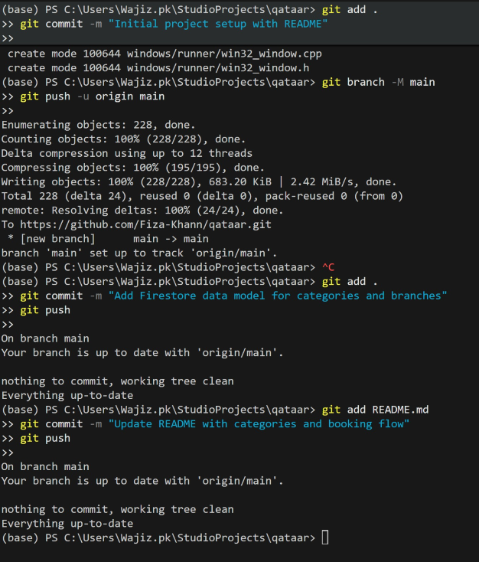
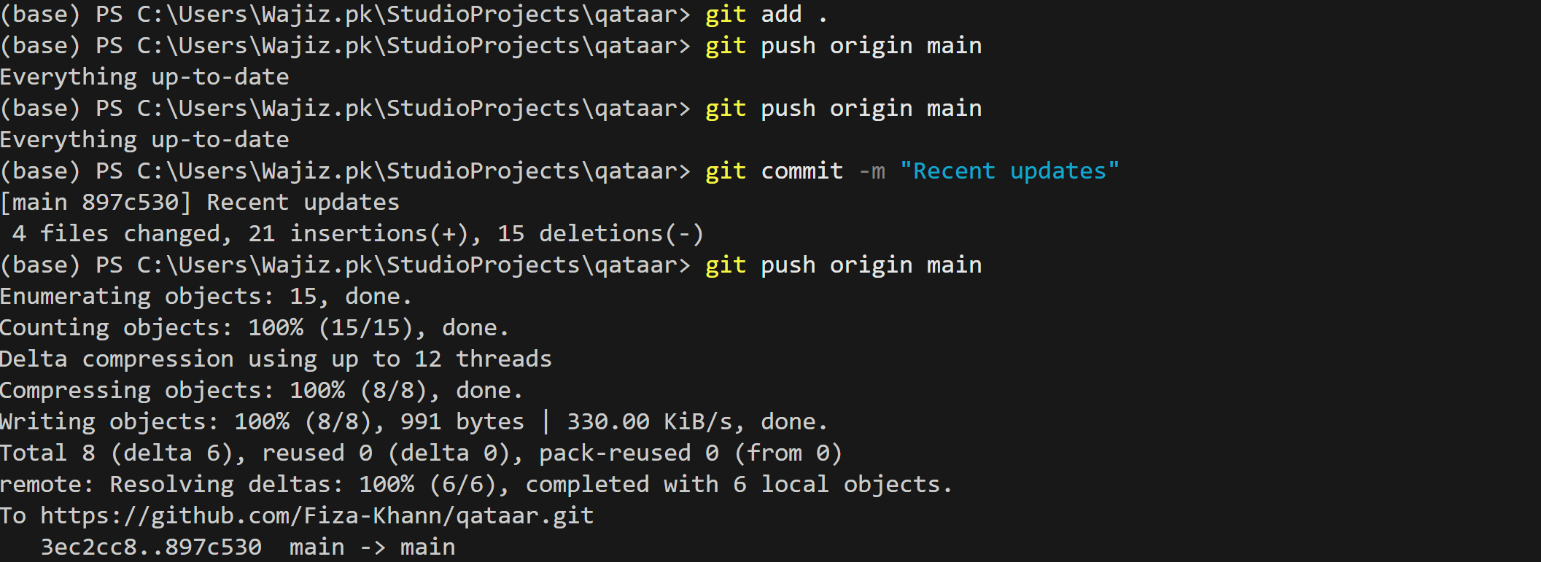
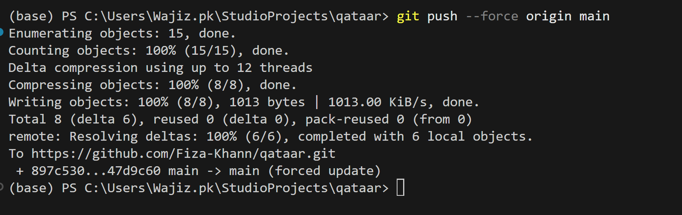

8.3 Branching Strategy
A feature-based branching strategy was adopted for the project. Separate branches were created for major modules such as authentication, queue management, notifications, and UI development
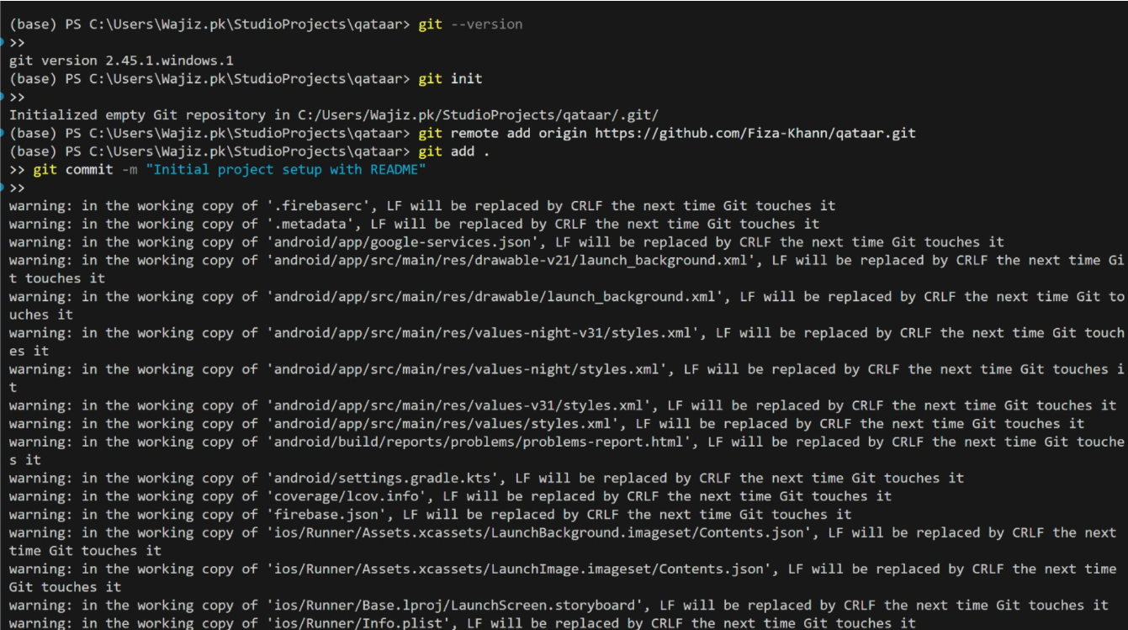

9.User Interface Documentation

9.1 Major Screens
The QATAAR application consists of several major user interface screens designed to provide a simple and intuitive user experience.
- Login Screen: Allows users to log in using email/password or Google authentication.
- Signup Screen: Enables new users to create an account by providing basic details.
- Home Dashboard: Displays available service categories and navigation options.
- Service Selection Screen: Allows users to select a service type and branch.
- Queue Status Screen: Shows the user’s current token number, queue position, and estimated waiting time in real time.
- Token History Screen: Displays previously generated tokens and their statuses.
- Notification Alerts: Inform users when the queue progresses or when their turn is near.
- Admin Panel: Provides service administrators with control over queue operations. Admins can monitor active queues, manage service categories, update queue progress, and oversee system activity in real time.
- Settings Panel: Allows users to update profile information, manage notification preferences, change passwords, and log out securely.
Screenshots of all these screens are included in the report to visually demonstrate system functionality.

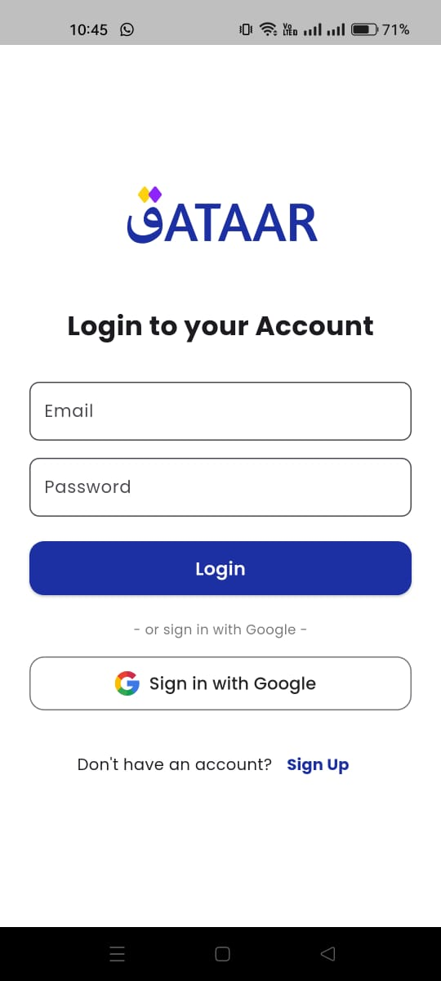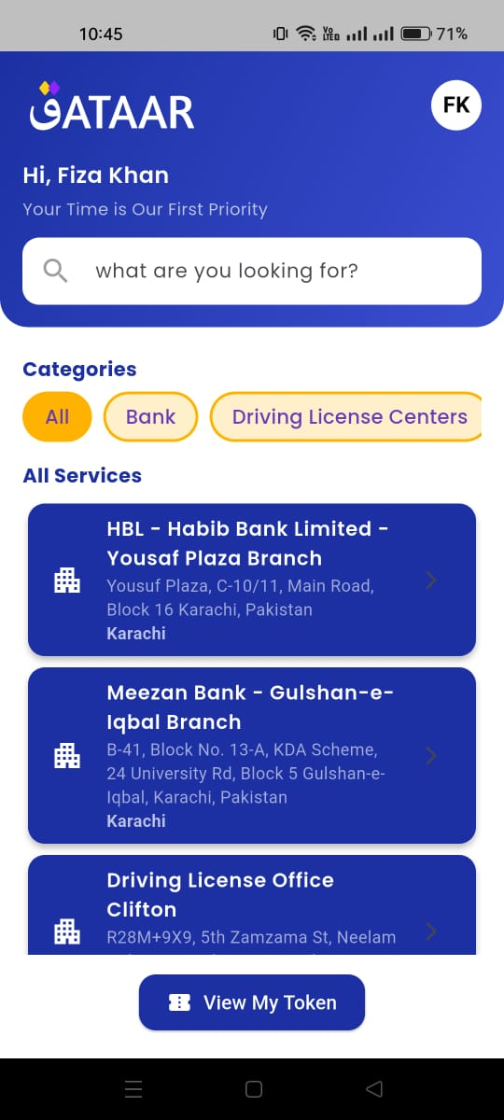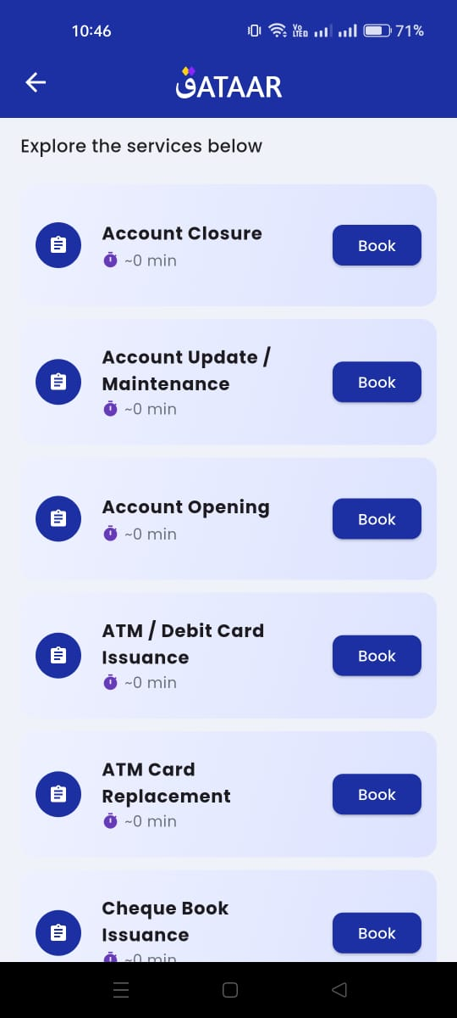

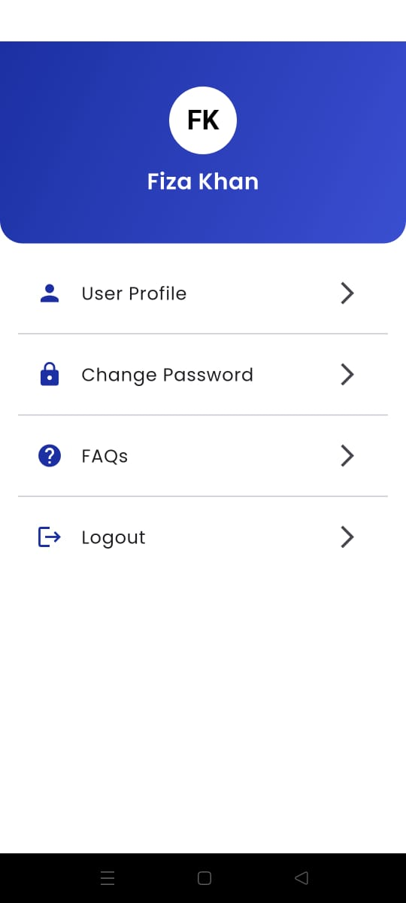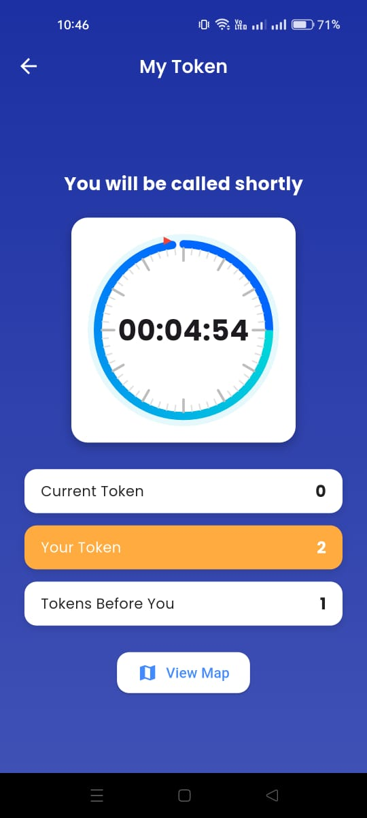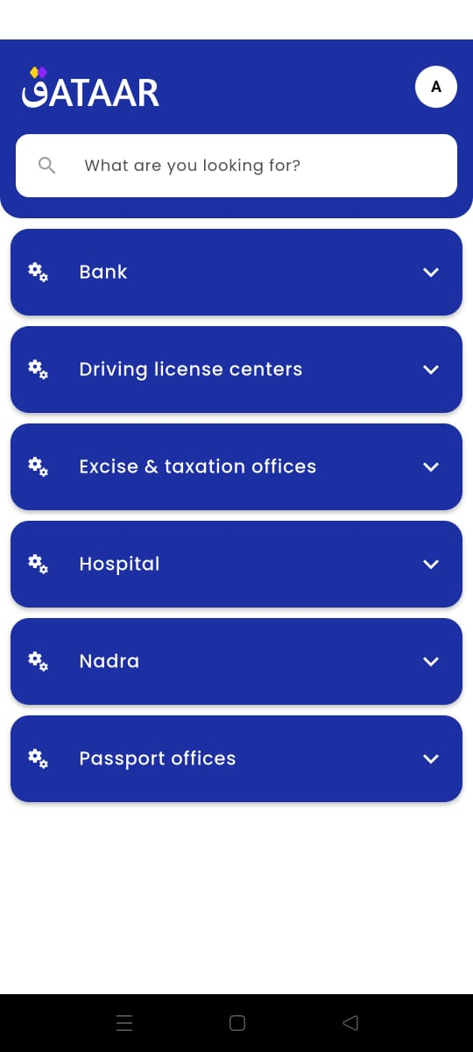

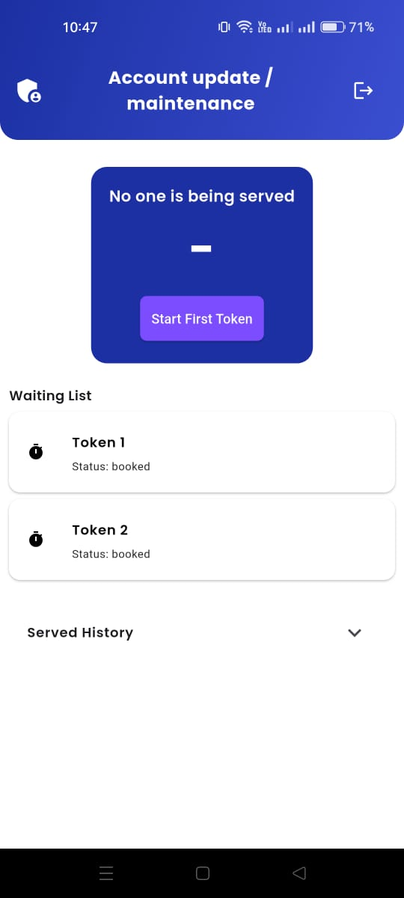

9.2 User Manual
The user begins by registering or logging into the application. After authentication, the user selects a service category and branch from the available options. Upon selection, the user generates a digital token, which is displayed along with real-time queue information. The user can monitor queue progress and receives notifications when their turn approaches. After service completion, token details are stored in the token history section for future reference.

9.3 Feature Demonstration
The system demonstrates key features such as remote token generation, real-time queue tracking, and push notifications. The queue status updates automatically without manual refresh, showcasing real-time synchronization. Location-based alerts and smart notifications further demonstrate the system’s ability to improve time management and reduce missed turns.

10. Challenges & Solutions

10.1 Challenges
One of the major challenges faced during the development of QATAAR was handling real-time queue updates efficiently. Since multiple users may generate tokens simultaneously, ensuring accurate and instant queue position updates without data conflicts was complex. Another challenge was implementing timely and reliable push notifications, as delays or incorrect triggers could negatively impact user experience.
Integrating location and traffic-based travel time estimation using Mapbox API also presented challenges. Managing API calls efficiently while maintaining application performance and accuracy required careful planning. Additionally, coordinating development tasks among team members and integrating different modules into a single system required consistent communication and version control management.

10.2 Solutions
Real-time updates were successfully implemented using Firestore real-time listeners, which ensured immediate synchronization of queue data across all users. Notification-related issues were resolved by defining clear trigger thresholds and optimizing Firebase Cloud Messaging logic. Location and traffic integration was optimized by limiting unnecessary API calls and caching essential data to improve performance.
To manage team collaboration and integration challenges, a feature-based branching strategy was used on GitHub, allowing parallel development and smooth merging of modules. These solutions collectively improved system stability, performance, and overall reliability

10.3 Lessons Learned
This project provided valuable practical experience in applying software construction principles to a real-world problem. The team gained a strong understanding of modular system design, which helped in developing, testing, and integrating different components efficiently.
Working with real-time databases highlighted the importance of handling data synchronization and performance optimization. The use of Firebase services improved understanding of authentication, cloud data management, and push notification systems.
The project also enhanced skills in team collaboration and version control. Using GitHub for branching and commits emphasized the importance of clear commit messages and structured development workflows. Additionally, the team learned the value of code refactoring, immutability, and clean architecture in maintaining readable and maintainable code.

11. Conclusion & Future Work
11.1 Project Achievements:
The QATAAR project successfully delivers a functional and efficient electronic queue management system. The application enables users to generate digital tokens remotely, track real-time queue progress, and receive timely notifications. The system effectively reduces physical waiting time and overcrowding at service centers. The successful integration of Flutter, Firebase, and Mapbox demonstrates the practical implementation of modern mobile and cloud-based technologies.
11.2 Future Enhancements:
Several features can be added to enhance the system in future versions. These include online payment integration for paid services, advanced analytics dashboards for service providers, and multi-language support to improve accessibility. Additional improvements may include role-based admin panels, appointment scheduling, and AI-based waiting time prediction.
11.3 Learning Outcomes:
This project provided hands-on experience in applying software construction concepts such as modular design, real-time data handling, and version control. The team improved technical skills in Flutter and Firebase, gained experience in collaborative development using GitHub, and developed a deeper understanding of building scalable and user-centric software solutions.
12. Appendices
12.1 Code Listings

12.1.1 Fetch User Name
Future<String> getUserName(User user) async {
final doc = await FirebaseFirestore.instance.collection('users').doc(user.uid).get();
return doc.exists ? doc['name'] ?? 'User' : 'User';
}

12.1.2 Branch Loading
Future<void> loadBranches() async {
try {
final categorySnapshot = await FirebaseFirestore.instance.collection('categories').get();
List<Branch> loadedBranches = [];

for (var categoryDoc in categorySnapshot.docs) {
final branchSnapshot = await FirebaseFirestore.instance
.collection('categories')
.doc(categoryDoc.id)
.collection('branches')
.get();

loadedBranches.addAll(branchSnapshot.docs
.map((doc) => Branch.fromDoc(doc, categoryDoc.id))
.toList());
}

setState(() {
branches = loadedBranches;
categoryIds = ['All'] + categorySnapshot.docs.map((d) => d.id).toList();
});
} catch (e) {
ScaffoldMessenger.of(context).showSnackBar(
const SnackBar(content: Text('Failed to load branches. Please try again.')),
);
}
}

12.1.3 Token Creation
Future<void> createToken(String userId, Branch branch) async {
final tokenRef = FirebaseFirestore.instance.collection('token').doc();

final tokenNumber = branch.currentToken + 1;
final estimatedWait = tokenNumber * branch.avgServiceTimeSec;

await FirebaseFirestore.instance.runTransaction((transaction) async {
final branchRef = FirebaseFirestore.instance.collection('categories')
.doc(branch.categoryId)
.collection('branches')
.doc(branch.id);

final branchSnapshot = await transaction.get(branchRef);
final currentToken = branchSnapshot['currentToken'] as int;

transaction.update(branchRef, {'currentToken': currentToken + 1});
transaction.set(tokenRef, {
'userId': userId,
'branchId': branch.id,
'categoryId': branch.categoryId,
'tokenNumber': currentToken + 1,
'status': 'active',
'issuedAt': FieldValue.serverTimestamp(),
'estimatedWaitSec': estimatedWait,
});
});
}

12.1.4 Search / Autocomplete
Autocomplete<Branch>(
optionsBuilder: (TextEditingValue textEditingValue) {
if (textEditingValue.text.isEmpty) return const Iterable<Branch>.empty();
return branches.where((branch) =>
branch.name.toLowerCase().contains(textEditingValue.text.toLowerCase()) ||
branch.city.toLowerCase().contains(textEditingValue.text.toLowerCase()));
},
displayStringForOption: (branch) => '${branch.name} (${branch.city})',
onSelected: (branch) {
Navigator.push(
context,
MaterialPageRoute(
builder: (_) => ServiceListScreen(
branchId: branch.id,
categoryId: branch.categoryId,
),
),
);
},
)

12.2 Additional Documentation

Firestore Data Model
Collections / Documents Structure:
categories (collection)
├── hospitals (document)
│ └── branches (subcollection)
│ ├── main-campus (document)
│ │ ├── name: "The Aga Khan University Hospital (AKUH)"
│ │ ├── city: "Karachi"
│ │ ├── location:
│ │ └── services (subcollection)
│ │ ├── general-consultation (document)
│ │
│ │
├── banks (document)
│ └── branches (subcollection)
│ └── branch-name (document)
├── nadra (document)
│ └── branches (subcollection)
└── driving-license-centers (document)
└── branches (subcollection)

token (collection)
├── token-id (document)
│ ├── userId: <uid>
│ ├── branchId: <branch-doc-id>
│ ├── categoryId: <category-doc-id>
│ ├── tokenNumber: 5
│ ├── status: "active" // or "completed"
│ ├── issuedAt: <timestamp>
│ └── estimatedWaitSec: 300

users (collection)
├── uid (document)
│ ├── name: "Ali Khan"
│ ├── email: "ali@example.com"

